Requirement Analysis
Data Flow Diagrams and User Flows
Date | November 2, 2025
Team ID | F53C03230D9D3649CD4402B24FF15FEB
project Name | Educational organization using ServiceNow

User Flow 1: Creating a New Admission
- User: Administrator
- Trigger: A new student applies.
- Flow:
  - Logs into ServiceNow.
  - Navigates to the "Admission" module in the "Salesforce" application.
  - Clicks the "New" button.
  - The "Admission" form loads. The "Admin Status" is "New".
  - Fills in Student Details (Name, Father's Name, etc.).
  - Selects a "Pincode".
  - SYSTEM: The onChange script triggers and auto-populates "City", "Mandal", and "District".
  - User fills in all other required fields.
  - User clicks "Submit".
  - SYSTEM: A new record is created with a unique "Admin Number" (e.g., SAL0000001).
  - The user is returned to the "Admission" list view.
User Flow 2: Updating Student Progress
- User: Administrator / Teacher
- Trigger: A student's marks for the term are available.
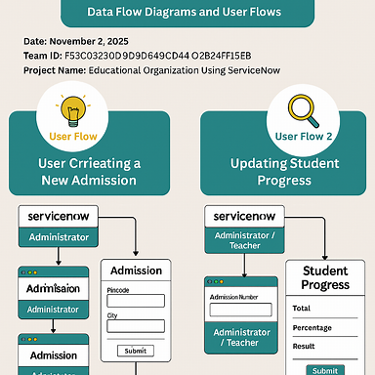
- Flow:
  - Logs into ServiceNow.
  - Navigates to the "Student Progress" module.
  - Clicks the "New" button.
  - The "Student Progress" form loads. Total, Percentage, and Result fields are read-only.
  - User clicks the search icon for the "Admission Number" field.
  - User selects the correct student from the list.
  - SYSTEM: The onChange script on "Admission Number" triggers and auto-populates the student's details (Name, Father's Name, etc.).
  - User enters the marks for all subjects (Hindi, English, Maths, etc.).
  - SYSTEM: With each entry, the onChange script on the subject fields triggers:
    - The "Total Update" script runs, calculating the sum and setting the Total field.
    - The change in Total triggers the "Percentage Update" script, which calculates and sets the Percentage field.
    - The change in Percentage triggers the "Result Update" script, which sets the Result field to "Pass" or "Fail".
  - User verifies the auto-calculated data.
User clicks "Submit".

